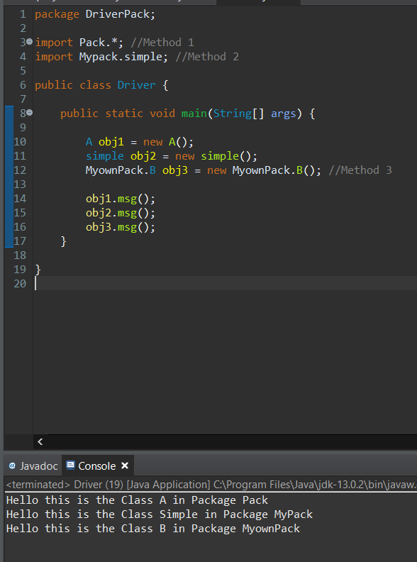

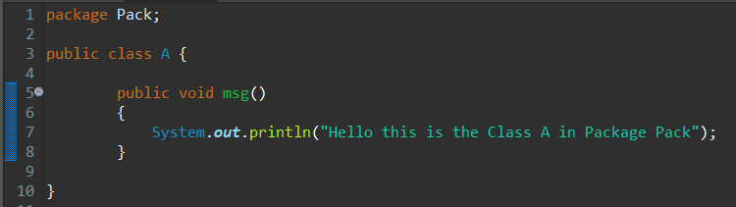

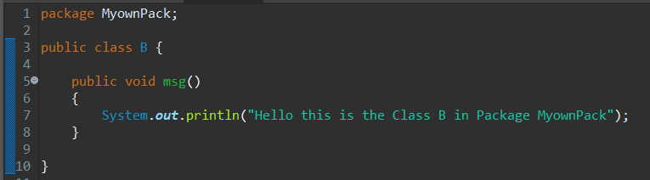

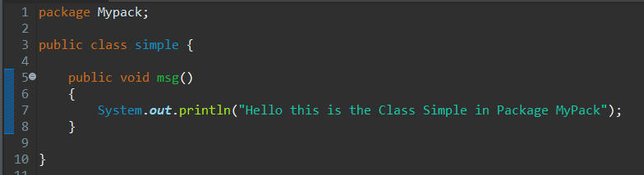

Here there are 4 packages.

Each package with have different messages in “msg()” method.

Here we have used three types of method to import a package of three different classes.

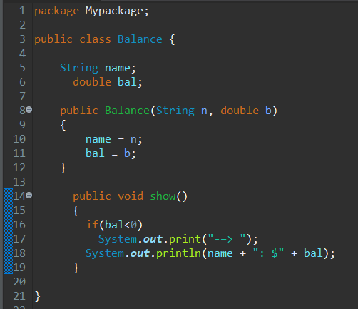

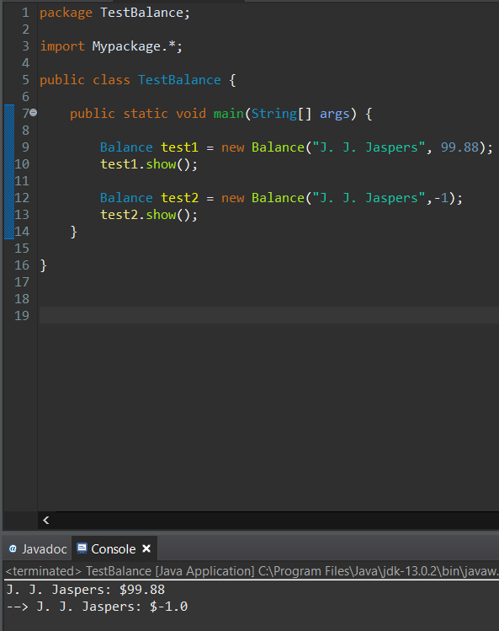

Here there are 2 packages.

It prints the output based on the balance member which is being instantiated when the constructor is called.

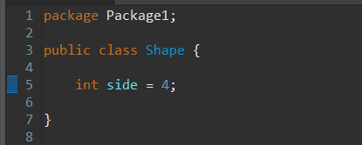

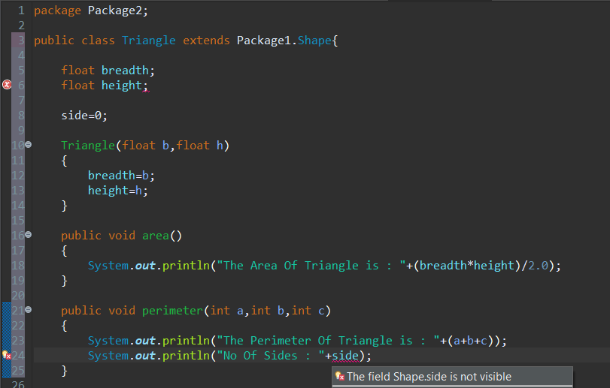

Here Since its default the member size is not visible since it’s the sub class of different package.

To make it visible we can use either public or Protected.

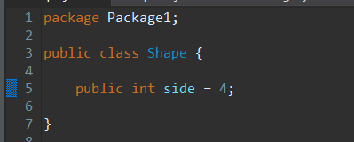

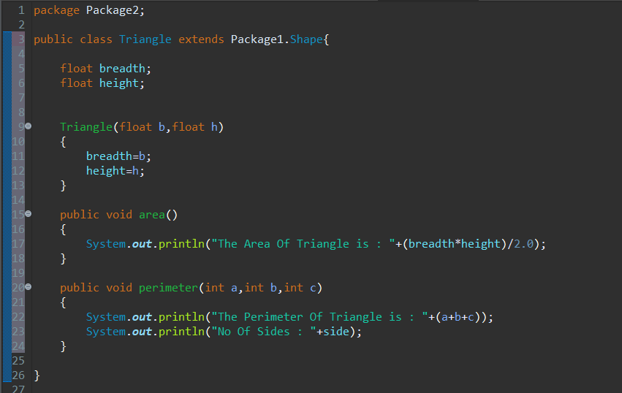

After making it public its visible in the sub class of “Package2”.

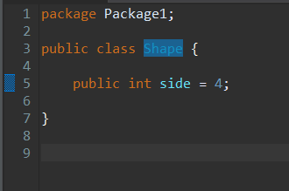

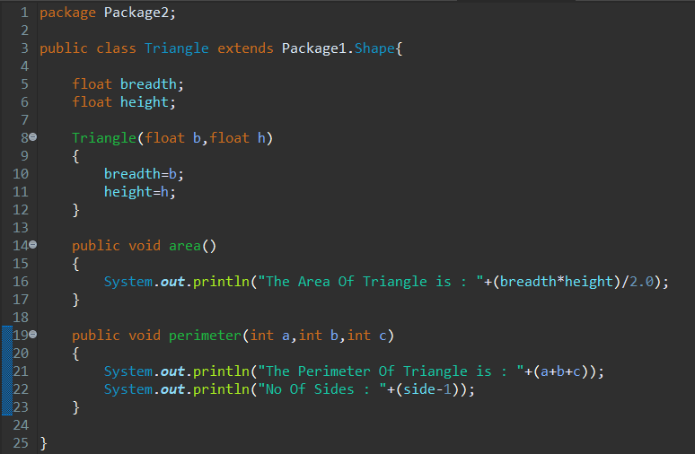

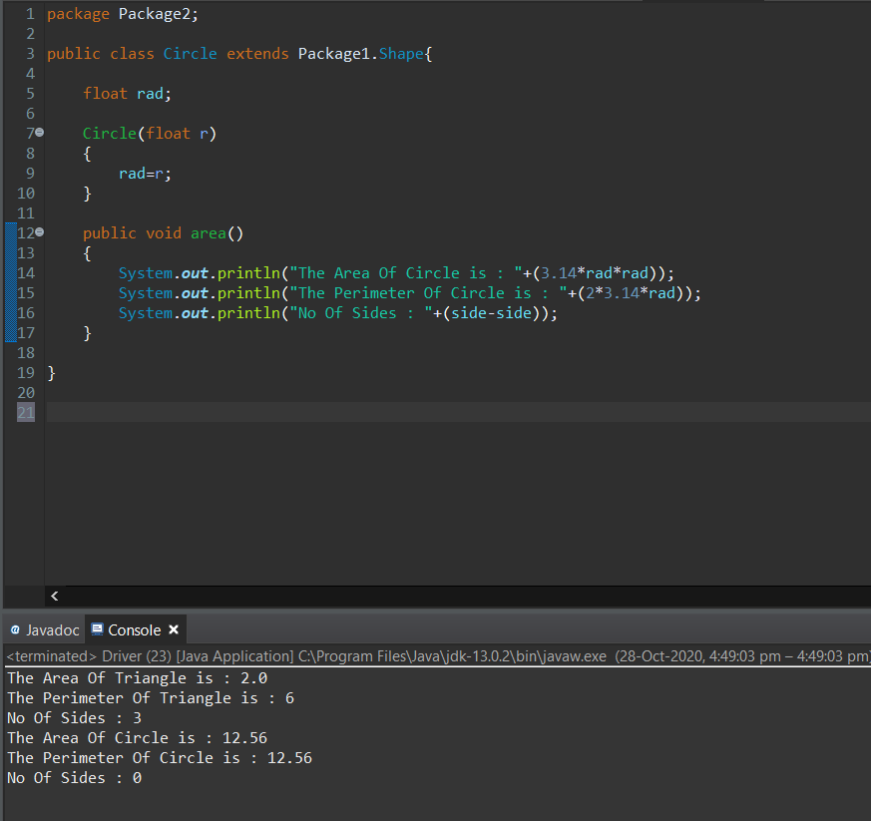

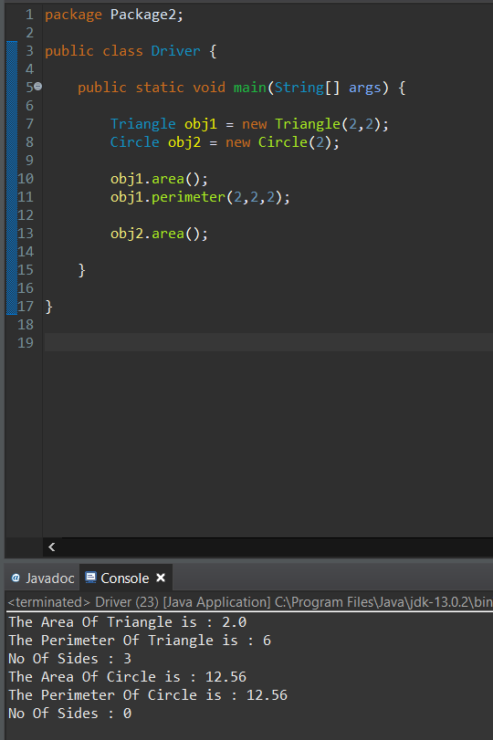

When the data member “side” is public it will be visible in subclasses of other packages also.

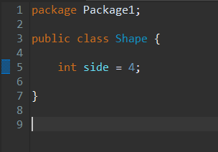

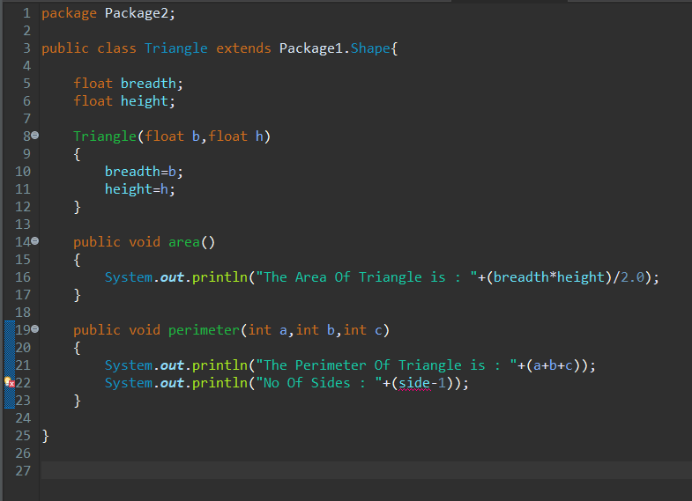

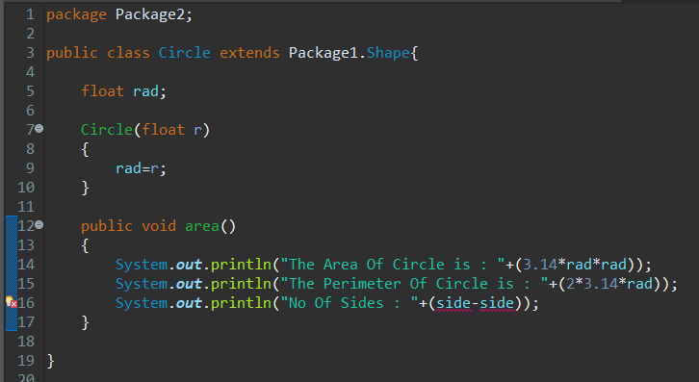

When the data member “side” is default it won’t be visible in subclasses of other Packages and throws an error.

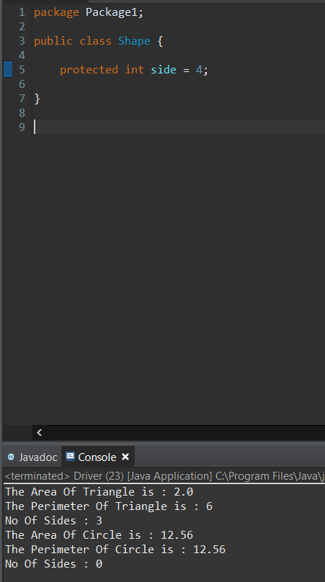

When the data member “side” is protected it is visible in subclasses of other Packages.

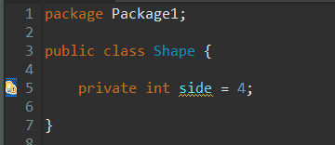

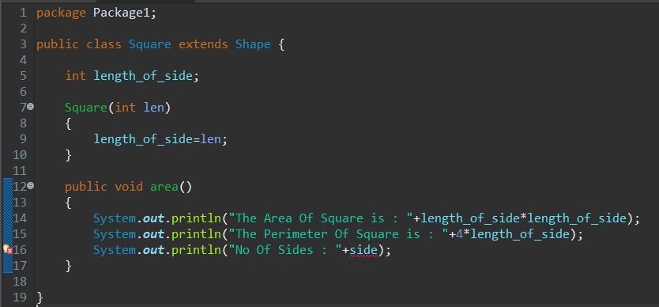

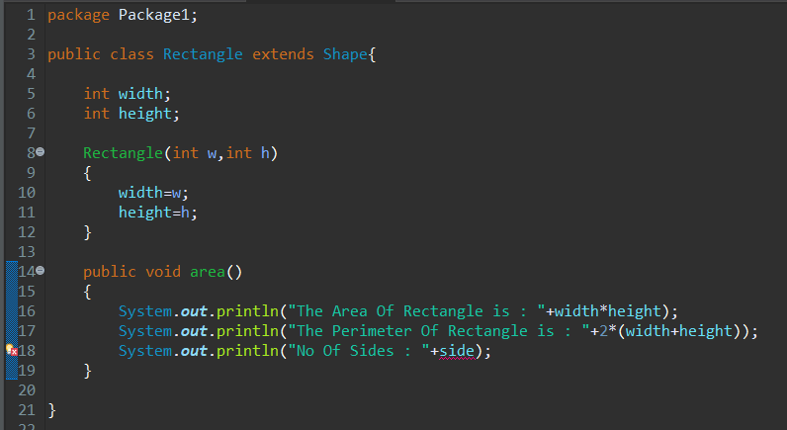

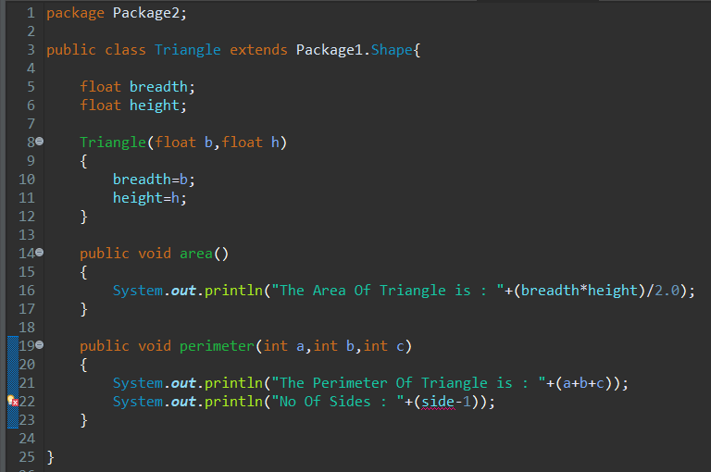

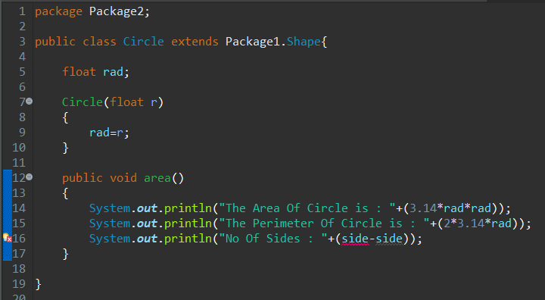

When the data member “side” is private it is only visible within its class.

So the data member “side” is not visible to the derived class “Square” and “Rectangle” in the same Package and it is not visible to the derived class “Triangle” and “Circle” in the other Package.